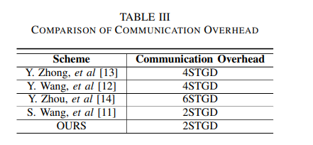
第十四篇文献换成下面这篇。
Learning with error‐based key agreement and authentication scheme for satellite communication | International Journal of Satellite Communications and Networking (acm.org)

Forward Security:那里改成Forward and Backward Security
内容部分改成
Forward security is ensured because each session key is derived independently; even if an adversary compromises a current session key, it does not provide access to previous session keys or communications. Backward security is ensured because each session key is derived independently; even if an adversary compromises a past session key, it does not provide access to subsequent session keys or communications.

